

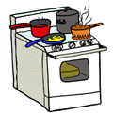**Individual Dinner Heating Instructions – Oven**

Preheat oven to 325 degrees

Remove plastic lid, roll, cranberry sauce, glaze or gravy containers

Pour gravy or glaze into the dinner container in desired location.

Cover the entire tray with aluminum foil.

Place the tray in the oven for 10 to 15 minutes or until the internal temperature reaches 165 degrees.

When you have 2 to 3 minutes left of re-heating time, place the bread in the oven to warm.

Happy Holidays!

Keep your dinner in the refrigerator overnight!

**************************************************************************************************

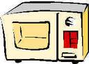**Individual Dinner Heating Instructions – Microwave**

Remove plastic lid, roll, cranberry sauce, gravy or glaze containers

Pour gravy or glaze over your dinner in the desired location.

Place meal in a microwave safe dish and cover with a microwave lid.

Heat on HIGH for approximately 3 minutes or until the internal temperature reaches 165 degrees.

Cut and toast the roll OR warm it in the oven.

Happy Holidays!

Keep your dinner in the refrigerator overnight!